Michael O`Neill. F.C.Pod.S. M.Ch.S.
Patient Info
15
Consultant Podiatric Surgeon

What you need to know about Your foot and Biomechanical Examination

Y

ou have been diagnosed with a painful foot or lower limb that may be due to an alteration in its normal function. This handout explains the background to your proposed treatment and some of the investigations that may be undertaken to assess the problem also for providing specialist orthotic controlling shoe inserts .

Podiatric Biomechanics:

Podiatric biomechanics relates to the study of Human mechanical motion in relationship to the problems that are either directly related to foot pain or how foot mechanics may have influenced the cause of other postural problems or have maintained or reduced the ability of the body to heal these injuries usually in the lower limb and back.

Treatments are usually a combination of mechanical control of the foot. Initially often involving strapping or padding. Then specially designed insoles (Orthotics) which alters how the foot works influencing the movement of the knees, hips and lower back. This combination allows healing, or helps the foot and limb work in a more functional position, preventing further injury. Rehabilitation exercises are also very important depending on your problem may also involve working with Physiotherapists, Osteopaths or Chiropractors.

To help achieve these results detailed evaluations are made as to how the injured area is influenced by the body’s mechanical and medical function.
This will involve assessing the range of motion of joints. Checking for muscle imbalances and assessing the nerve and blood supply. As well as an overall review of your general health, past injuries, previous treatments and medication used.

SPECIALIST TESTS
Depending on the severity, location of pain or injury. Consideration will be given to using the following

- X rays
- Diagnostic Ultrasound
- MRI or CT scans.
- Blood tests

These tests are used to see the exact location and extent of the problem.

Gait Analysis

Watching the body working is very important. Gait analysis is used (sometimes with a treadmill) and may involve a video so the motion may be slowed down to review specific actions that occur to quickly for the human eye to see. This allows us to measure exact range of foot and limb movement.
Dynamic Pressure and Gait Analysis ( F Scan)
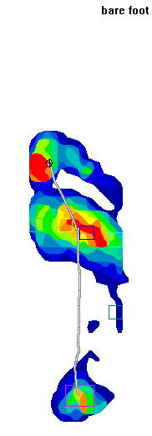
This diagnostic test is used to observe how the foot is placed on the ground showing how the pressures and forces are taken by the foot.

This test also identifies how foot joints may be not working efficiently therefore resulting in restricting or increasing desired motion.

Dynamic analysis also indicates how walking and running may be altering the centre of gravity, influencing abnormalities and forces on the rest of the body.

For specific sports these tests may be undertaken within a sports facility.
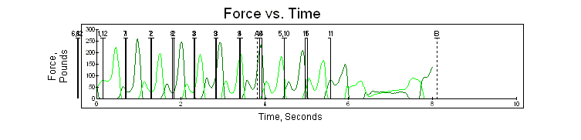
Orthotics

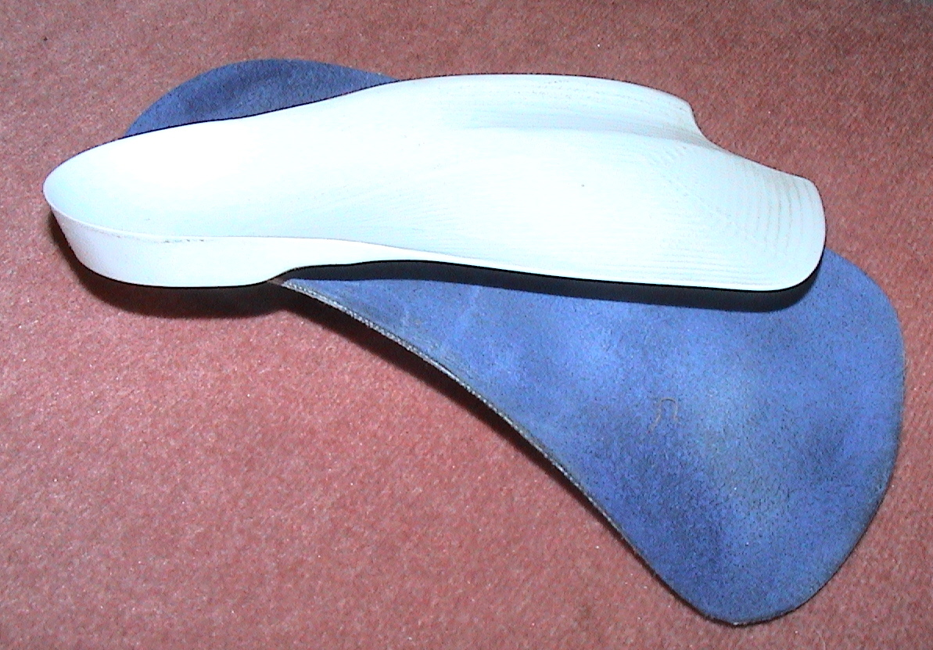
These are special shoe inserts that help to control and improve the foot and lower limb function. Sometimes used to rest an injured area or to increase the use of an area that is not fully functioning. Temporary orthotics are often produced in clinic to assess their effectiveness. If permanent devices are prescribed the exact shape of the foot is captured by casting the foot in plaster of Paris producing an exact copy of the foot contours. These are then laser scanned to produce a permanent record. The orthotics are produced depending on the results of the tests and investigations previously made.

What to wear and bring with you for the tests.
If a sports related problem please bring with you sportswear, i.e. shorts and T-shirt, footwear must include trainers and normal day shoes.
For non sports problems loose fitting clothes that can be rolled above the knees.

Bio-mechanic tests can not be done in Sandals or high boots (Apart from Walking boots)

