Michael O`Neill F.C.Pod. (Surg),

Consultant Podiatric Surgeon

The Princess Margaret Hospital

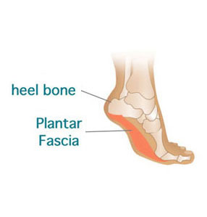01753 857512

HEEL PAIN (Plantar Fasciitis)

What is Plantar Fascitis?

Heel pain is suffered by many people, young and old, sporty and inactive.

Sometimes, specific events precede heel pain, for instance, a fall, landing heavily on the heel or a long days shopping, a change of occupation, or increase in weight. Also some sporting activities i.e. running or jogging. in improperly fitting or excessively worn shoes. Often no memorable event has taken place and the pain slowly develops over days or weeks.

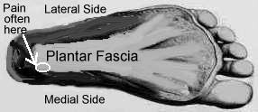
Usual Symptoms

Pain is often located on the underside, or inside of the heel, sometimes radiating into the arch and sole of the foot or up into the ankle.
Pain is typically present in the morning when taking the first few steps of the day, usually reducing over the following 10-20 minutes. Similar pains may occur after sitting for a short period of time.

A second type of pain is often experienced when standing for long periods, or walking. This is often described as a dull ache or a deep bruised sensation, which usually occurs in one foot but may develop in both.

Why These Pains Develop

The plantar fascia is a fibrous sheath that runs most of the length of the sole of the foot. It attaches between the heel bone and the bones at the base of the toes, covering the small muscles in the sole of the foot. During walking and running, the plantar fascia becomes tight and helps the foot act as a lever to push off with force.
Plantar fascitis refers to inflammation of the plantar fascia, usually at the point where it attaches to the bone.

TREATMENT of HEEL PAIN

The treatment may vary according to your symptoms, and duration of pain, occupation, recreational activities, etc

- The Principles of treatment is to support the inside arch of the foot increase shock absorption and reduce inflammation. This will reduce pain .

Medication May be used to reduce pain and inflammation

The first pain to be reduced ( if treatment is working) is the early morning pain when you get out of bed.

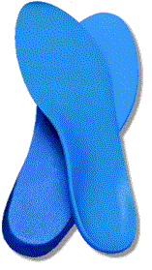
Padding, Orthotics (Insoles)

Treatment may be commenced with padding or strapping stuck onto the foot for several weeks in the acute phase. Followed with Insoles to support the arch and provide shock absorption for the heel. These may be a simple design or more complex one requiring a cast made of the foot in order to make a specialised individual device. These are to be worn constantly inside all footwear. They may have to be worn at least 3 months after all pain has gone. Even then you may well have specific foot problem that caused the initial pain and may always have to use orthotics.

Footwear
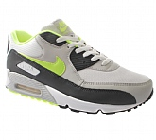
Shock absorbing, supportive footwear is essential. Unless this strictly adhered to, then the rest of the treatment will not be effective.
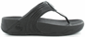
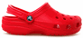
Trainers are ideal, or thick cushioned shock absorbing heels and soles. Avoid slippers, sandals and thin soled shoes. Bare feet must be strictly avoided. Expect to wear this footwear for a minimum of 3 months.

Stretching.

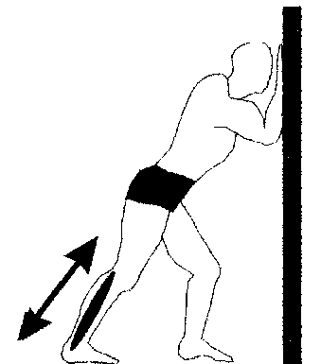
Calf Stretch1. Facing a wall, put your hands against the wall at about eye level. The side to be stretched is behind with the heel just off the floor. Lean forward and down until you feel stretching in the calf of the straight leg. Hold for 30 seconds repeat 5 times and do 3 times a day.
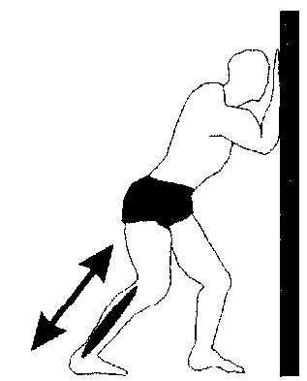
Calf Stretch 2 In a similar position as calf stretch 1 Bend the Knee Slightly (to stretch other muscles)Then again bend forward downwards and push your heel towards the floor. Hold for 30 seconds repeat 5 times and do 3 times a day.

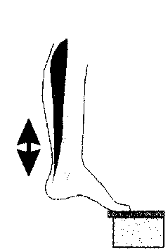
Foot Stretch Standing with the ball of the injured foot on a stair and slightly toed in, reach for the bottom of the step with your heel until you feel a stretch in the arch of your foot. Hold for 30 seconds repeat 5 times and do 3 times a day.

Hamstring Stretch (Above Knee and back of Leg)

Lie with back on floor, one leg bent, one leg straight. Lift straight leg towards ceiling as far as you can and hold for 15-20 seconds. Repeat twice a day.

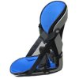

Night Splint
These are designed to hold your foot up while resting and are worn in bed.
This helps people who complain of severe pain after rest, especially in
the morning.

Ice and Deep ice Massage

Ice is very effective at reducing swelling and pain.
Keeping socks on to avoid an ice burn.

1. Place the heel on an ice pack for fifteen minutes three times a day.

2. Deep ice massage. Use a small plastic soft drink bottle.

- Fill nearly to top with water.
- Do not put lid on
- Place in freezer
- Once frozen Replace lid
- Place a towel on the ground in front of armchair and put bottle on towel .
- Roll foot over bottle from heel to toes pressing well up into the arch area. Ideally for 10 minutes three times a day.

Weight
A recent increase in weight often causes problems: Weight loss will be beneficial.

Physical Therapy
The podiatrist may undertake or send you to another member of the health care team to have, Manipulations, soft tissue mobilisation, laser or ultrasound.

Injections
Sometimes injections may be used into the heel if pain is not responding to the physical Therapies. These are steroid injections and you may require more than one.

Surgery
Very rarely if the pain has been present for a very long period and causing distress then surgery may be undertaken to relieve the tension off the plantar fascia and heel bone.

