Michael O`NEILL F.C.POD s
Patient Info
3
CONSULTANT pODIATRIC SURGEON

Foot Surgery Mortons Neuroma and Metatarsal Bursitis

Surgical Information Pack

Mortons Neuroma
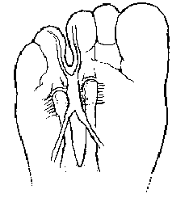
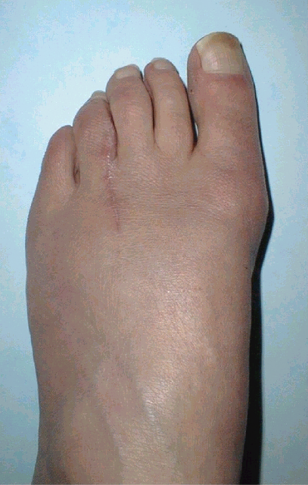

----------The Neuroma Neuroma
Site Healed

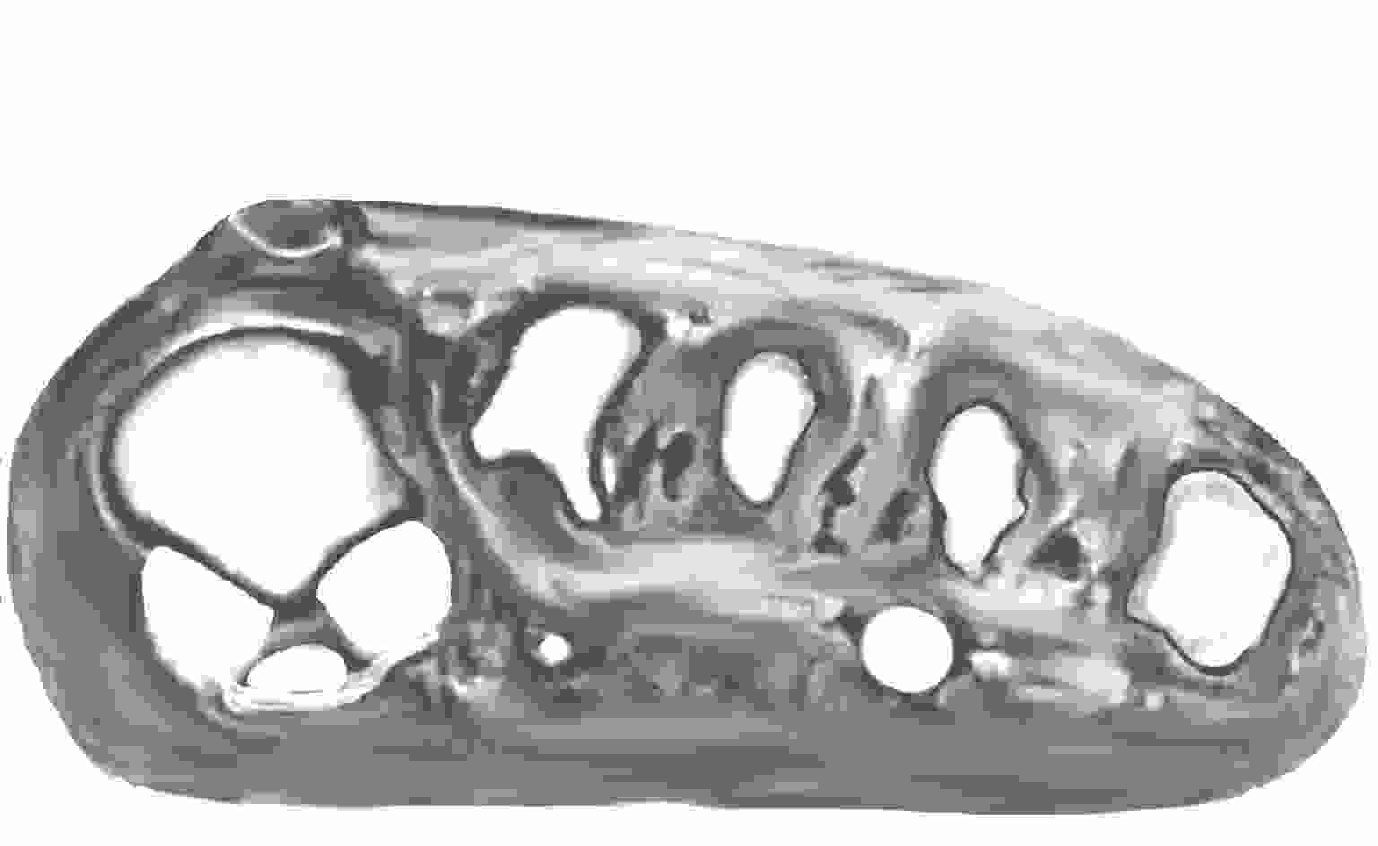
Diagram of Morton’ Neuroma Photo 8 Weeks After Surgery

----------The Neuroma

Cross Section showing Morton’ Neuroma

Plantar neuroma or Morton's Neuroma (or fibrous lump on the nerve) is a cause of a painful forefoot which is not related to an outward deformity of the foot. Classically it is located between the 3rd & 4th metatarsal heads, but it can occur between others.
Non surgical methods such as orthoses and / or steroid injection occasionally help but, when well established, the only satisfactory curative treatment for this painful condition is excision of the neuroma usually through a small incision on the top of the foot.

What you need to know about Undergoing your Foot Surgery
Read The Following Pages with Care

You have been diagnosed with a painful forefoot (Mortons Neuroma) that has not respond to conservative care or its history and pain levels suggest would not be suitable for non surgical options this has been Previously discussed with you

This pack reminds you of points previously discussed

What is a Mortons Neuroma Page 2

What will happen on the day of your surgery. Page 4

Post Operative Advice Page 5

Pain Control Page 7

Removal of Stitches Page 8

After Surgery Care Program Page 9

What to expect following surgery

Risks and complications Page 10

Foot Exercises Page 11

THE DAY OF YOUR SURGERY

- A parent or guardian must accompany all patients under 16 years of age.
- You do not need to fast. (UNLESS SEDATION IS BEING USED)
- You may have a light breakfast/light lunch.
- Please remove all nail polish, trim and clean your nails.

ON ARRIVAL TO THE HOSPITAL
Please report to main reception in good time. Please do not bring with you any valuables or excess money. Nursing staff will arrange for you to have an antiseptic foot wash and you may be required to change into a gown that is provided for you.
Your foot will be heavily bandaged afterwards so do not wear tight trousers. Track suit bottoms or a skirt are ideal.

THE OPERATION
The operation is usually performed under a local anaesthetic, usually around the ankle, and most patients find this to be more comfortable than a dental injection. will be awake throughout the procedure.
The operation takes about 50 minutes, although you will be in the Day surgery Unit for some time before the surgery and afterwards, to allow you an opportunity to rest post operatively
Do not worry – you will not feel pain and will be able to chat to staff or listen to music.

POST OPERATIVE ADVICE
☞
Note The following is a list of important points to remember:
.
- Under no circumstances should you put weight on the affected foot unless told to do so by Mr O`Neill
- Your foot will be heavily bandaged and you will be required to wear a special post-operative shoe.
- Before leaving hospital Mr O`Neill or Physiotherapy will explain how much weight you are allowed to put on the foot, will provide crutches, also show you how to walk.
- Go home immediately after your surgery and elevate your foot/feet on the way if possible. Do not travel on public transport.
- No transport facilities are available to take you home; therefore it is important that you arrange for someone to escort you home by car. You shall also need to arrange for transport for your out-patients’ appointments, until such time you are advised to drive or use public transport.
- When you go home, it is important that someone is there to look after you for the first few days. It may be more convenient for you to stay with family/friends, if they cannot come to stay with you, (if so we must be given a contact number).
- Rest and elevate foot at all times is very important for the first three days. This is extremely important to allow healing to take place, to minimise discomfort and to reduce post-operative swelling that can persist for quite some time following surgery.
- When absolutely necessary you may walk using the crutches or stick provided walking on your heel.
- If instructed apply ice packs over the top of the dressing every 4 hours during the day.

- Under no circumstances should you remove the dressing. You must keep the dressing dry, clean and intact. Do not change your own dressing. If the dressing becomes loose, or bleeding persists, ring the number below. Some dressings act as a splint. If you have a dressing changed at the GP or Accident and Emergency Department contact us as soon as possible.
- If you fall or accidentally hurt your foot please advise immediately.
- You will be unable to go to work and time of absence will vary according to the type of surgery proposed. We will give you a certificate to cover your absence from work, which you should give to your employers.
- Until advised you must not undertake any of the following activities:
*Driving * Return to work * Sport
*Wear usual footwear * Remove the bandage * Bathe the foot
*Shopping

- You are required to attend the outpatients clinic after your surgery, and your first appointment will be approximately four to seven days after your surgery.
- Approximately ten days after the surgery, your sutures (stitches) will be removed.
- After surgery you will be given a post-operative shoe. We ask that you wear this whilst you have the stitches in. After surgery it is possible that your foot may swell and you may have to wear an open type of shoe for a month or more. Care has to be taken to ensure that the shoe does not rub on the surgical scar line. You may need new shoes – if this is the case, please have your foot measured and advise the shop assistant that you have had foot surgery.

Pain Control

- The effect of the local anaesthetic injections given, should ‘wear off’ after about 5 – 6 hours, but this may vary considerably. While the numbness remains please take care not to injure it.
- Everyone has a different pain threshold, but experience shows that the first 48 hours are the most uncomfortable. Resting and elevating your foot will help minimise pain.
- Often there is little post-operative pain, this may mislead you into thinking you can do more than you should.
- Elevate your foot six inches above your hip on a soft cushion or pillow for 48 hours – this helps healing and reduces post-operative pain and swelling. Keep walking to a minimum.
- Do not climb steps/stairs unless it is absolutely necessary, e.g. going to bed.
- Use a bed cradle (use an upside-down cardboard box) if the weight of the bedclothes causes a problem to the operative area.
- Take your painkillers at the dose directed on the instructions five hours following your surgery.

- If you are worried or need further advice please phone
  - Mr O`Neill on Mobile 07768936052 or
  - pager 07654500289 (24 Hrs)

Following Suture Removal or Trimming

Now that your sutures have been removed or trimmed, it is very important for you to return, gradually and carefully, to normal activity over the next few weeks. Although the skin may be healed and the foot looks and feels fine, it is still healing inside. It is important therefore that you do not try and do too much too soon which will cause unnecessary bruising and discomfort.
Please follow the tips below.

- Keep your foot dry and the dressing in place for two days.
- After two days you may wet your foot. A warm saline footbath daily will help (a bowl of warm water with one or two teaspoons of salt added).
Do not soak your foot for longer than 5 minutes.
If you still have steri-strips in place leave them to come off in their own time. A little hand or face cream may be massaged into the area of the wound after such footbaths.
- It is not necessary to keep the dressing on but some people find it more comfortable to wear a thin piece of gauze over the incision site until it is less sensitive.
- You may now start wearing soft lace shoes or trainers. Use common sense and wear them only for short periods to start with at the beginning of the day, then gradually increase wear. As a general guide wear your shoes for an hour for the first few days then increase daily by half to one hour until wearing them all day around the house.
- It is normal for your foot to feel a little squashed in your shoe to start with as you have been wearing our loose black post-op shoe for some time.
- Do not worry about swelling and puffiness, it takes several months for all this to go away. Continue to use ice packs as necessary.

- Keep our next review appointment, as it is important to monitor your progress

What to expect after surgery

After The Operation
You must have a competent adult at home for the first day and night after surgery. This allows us to be sure you will be safe for the first night.
The First 3 Days* After Surgery
You will be able to stand and take weight carefully after the operation, but you must rest, with your feet up, as much as possible. You should restrict your walking to going to the bathroom. You can get about a little more after 3 days.
After 7 Days*
About 7 days after surgery, you must attend for a redressing. The operation site will be examined and redressed, and you will be given advice on gently increasing activity.
After 10 Days*
Between 10 and 14 days the stitches are removed (or trimmed if absorbable), as the skin will have healed. You will be able to gradually start returning to your normal footwear.
After about 8 Weeks
Over the 8 weeks following surgery, the foot returns more to normal and you should be back in normal footwear. You may return to work from about 4 weeks around this time (depending on your work and the type of footwear in which you are allowed to return to work). For a heavy job, return to work in under 8 weeks would be an unrealistic expectation. Obviously other factors such as; the severity of the deformity, tissue quality, circulation and general health can also make a difference. Although the foot should now be comfortable and returning to normal, there will still be noticeable swelling, particularly towards the end of the day. This is normal and to be expected as feet and legs are very prone to swelling anyway.
After 6 Months
The residual swelling should now be slight, if not completely resolved.
12 Months after Surgery
The foot has by this stage stopped improving, all healing is complete.

* NB if the operation involves an incision in the sole of the foot, you should not bear weight on that foot for 3 weeks after the surgery.
Problems / Risks Associated with Neuroma Excision Surgery
- Thickened scar and/ or tender scar - may reduce over 12 months
- Areas of numbness - may reduce over 12 months
- Infection (sudden increase in pain and swelling at 2 to 3 days after surgery - or later)
- Regrowth of nerve from resection site / entrapment of nerve stump within scar tissue - requiring steroid injection therapy or re-excision possibly through a plantar incision
- Thrombosis of the leg may follow any surgery Therefore it is very important to maintain ankle movement exercises and report any feeling of pain in the leg ,rise in temperature or generally feeling unwell.
- Rarely pain may develop in a foot after any trauma or operation that continues long after the expected heeling period (Complex regional pain syndrome)
Exercises Following Neuroma / Ganglion Removal Surgery

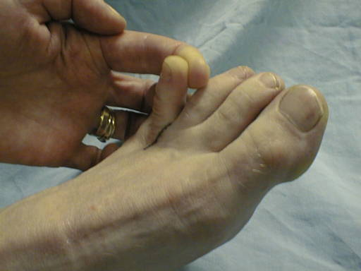

Day 1 onwards
gently move your foot up & down at the ankle 15 times every 30 minutes when resting

Day 3 onwards
start gentle active movement of toes (wiggle) for 2 minutes– 5 times a day

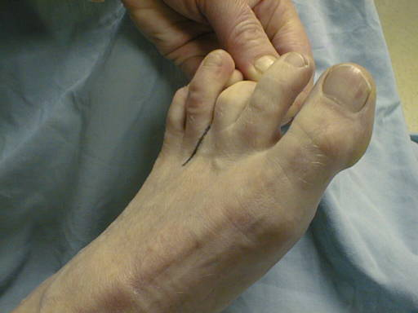Day 12 – 14 onwards
(after stitch removal or trimming)– start moving the toes that lie on each side of the scar, with your fingers (see pictures). Move the toes to the extreme of their motion (just to the point when discomfort is felt). Do this 3 times a day -10 times in each direction.

