Michael O`Neill F.C.Pod. (Surg),
Fellow of The College of Podiatry
Consultant Podiatric Surgeon
The Princess Margaret Hospital
01753 857512

HEEL PAIN (SEVERS HEEL)

What is heel pain in children (Severs disease or Calcaneal apophysitis):

Heel pain, unlike the heel spurs, that occur in adults is very uncommon in children. Of those children who do get heel pain, by far the most common cause is a disturbance to the growing area at the back of the heel bone (calcaneus) where the strong achilles tendon attaches to it. This is known as Sever's disease or calcaneal apophysitis (inflammation of the growth plate). It is most common between the ages of 9 to 14 years of age. These are one of several different 'osteochondroses' that can occur in other parts of the body, such as at the knee (Osgood-Schlatters Disease).

The anatomy of heel pain in the child (Severs disease or Calcaneal apophysitis):

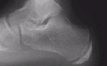
When a baby is born, most of the bones are still cartilage with only some starting to develop into bone. When the heel (calcaneus) starts to develop bone, there is generally one large area of development that starts in the center of the cartilage heel. This area of bone spreads to 'fill up' the cartilage. Another area of bone development (ossification) occurs at the back of the heel bone - see the x-ray to the right. These two areas of developing bone will have an area of cartilage between them - this is how the bone grows in size. At around age 16, when growth is nearly complete, these two bony areas fuse together. Sever's disease or calcaneal apophysitis is usually considered to be due to damage or a disturbance in this area of growth.

The two growth areas of the calcaneus can be seen on this x-ray.
The smaller area to the back of the heel is normal. Notice the small cartilage joint between the two.

What are the symptoms of heel pain in the child (Severs disease or Calcaneal apophysitis):
Pain is usually felt at the back and side of the heel bone. Sometimes there may be pain at the bottom of the heel. The pain is usually relieved when the child is not active and becomes painful with sport. Squeezing the sides of the heel bone is often painful. Running and jumping make the symptoms worse. One or both heels can be affected. In more severe cases, the child may be limping.
What causes heel pain in children (Severs disease or Calcaneal apophysitis):

The cause of Sever's disease is not entirely clear. It is most likely due to overuse or repeated minor trauma that happens in a lot of sporting activities - the cartilage join between the two parts of the bone can not take all the shear stress of the activities. Some children seem to be just more prone to it for an unknown reason - combine this with sport, especially if its on a hard surface and the risk of getting it increases. It can be almost epidemic at the start of some sports seasons, especially winter. At the start of winter, the grounds are often harder, but soften later. Children who are heavier are also at greater risk for developing calcaneal apophysitis.
A tight calf muscle is also common in those who develop calcaneal apophysitis - if you look at the x-ray above, you can imagine how much pull there is from the calf muscles via the achilles tendon on the small growth plate at the back and the strain that this will place on the cartilage join between them. A pronated foot (a foot rolled in at the ankle) is also more common - it is assumed that this may cause an uneven weight bearing on the back part of the heel bone.

TREATMENT of SEVERS HEEL

The treatment may vary according to your symptoms, and duration of pain, occupation, recreational activities, etc

- The Principles of treatment is to support the inside arch of the foot increase shock absorption and reduce inflammation. This will reduce pain .

Medication May be used to reduce pain and inflammation

Cut back on sporting activities - don't stop, just reduce the amount until symptoms improve (if the condition has been present for a while, a total break from sport may be needed later)
Avoid going barefoot

Padding, Orthotics (Insoles)
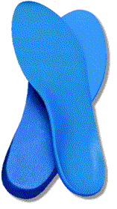
Treatment may be commenced with padding or strapping stuck onto the foot for several weeks in the acute phase. Followed with Insoles to support the arch and provide shock absorption for the heel. These may be a simple design or more complex one requiring a cast made of the foot in order to make a specialised individual device. These are to be worn constantly inside all footwear. They may have to be worn at least 3 months after all pain has gone. Even then you may well have specific foot problem that caused the initial pain and may always have to use orthotics.

Footwear
Shock absorbing, supportive footwear is essential. Unless this strictly adhered to, then the rest of the treatment will not be effective.
Trainers are ideal, or thick cushioned shock absorbing heels and soles. Avoid slippers, sandals and thin soled shoes. Bare feet must be strictly avoided. Expect to wear this footwear for a minimum of 3 months.

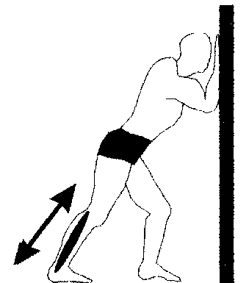
Stretching: Calf Stretch1. Facing a wall, put your hands against the wall at about eye level. The side to be stretched is behind with the heel just off the floor. Lean forward and down until you feel stretching in the calf of the straight leg. Hold for 30 seconds repeat 5 times and do 3 times a day.
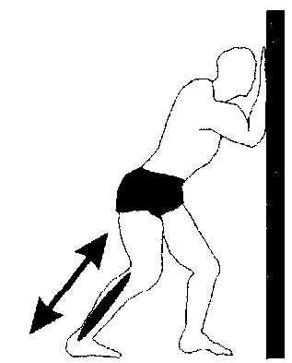
Calf Stretch 2 In a similar position as calf stretch 1 Bend the Knee Slightly(to stretch other muscles)Then again bend forward downwards and push your heel towards the floor. Hold for 30 seconds repeat 5 times and do 3 times a day.
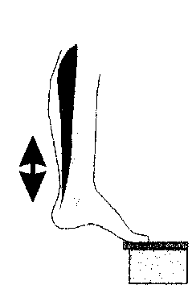
Foot Stretch Standing with the ball of the injured foot on a stair and slightly toed in, reach for the bottom of the step with your heel until you feel a stretch in the arch of your foot. Hold for 30 seconds repeat 5 times and do 3 times a day.

Hamstring Stretch (Above Knee and back of Leg) Lie with back on floor, one leg bent, one leg straight. Lift straight leg towards ceiling as far as you can and hold for 15-20 seconds. Repeat twice a day.

Ice and Deep ice Massage
The use of an ice pack after activity for 20mins is often useful for calcaneal apophysitis - this should be repeated 2 to 3 times a day.
Ice is very effective at reducing swelling and pain.
Keeping socks on to avoid an ice burn.

Physical Therapy
The podiatrist may undertake or send you to another member of the health care team to have, Manipulations, soft tissue mobilisation, laser or ultrasound.

Casting
If the symptoms are bad enough and not responding to these measures, medication to help with anti-inflammatory may be needed. In some cases the lower limb may need to be put in a cast for 2-6 weeks to give it a good chance to heal.

